NAME : K.LAHARI

REGISTER NUMBER : 192124027

COURSE CODE : CSA0520

COURSE NAME : DATABASE MANAGEMENT FOR DATA ANALYTICS

##### ~~Qu~~ IN & BETWEEN

1. List the type of the courses “Statistics” and “Programming”
2. The instructor wants to know the CourseNos whose scores are in the range 50 to 80

##### AGGREGATE

1. Find the average mark of “C002”.
2. List the maximum, minimum mark for “C021”
3. List the maximum, minimum, average mark for each subject in 5th semester
4. List the name of the courses and average mark of each courses.
5. Calculate the sum of all the scores.
6. How many students are registered for each course? Display the course description and the number of students registered in each course.

How many courses did each student register for? Use Assessment table

OUTPUTS:

1)

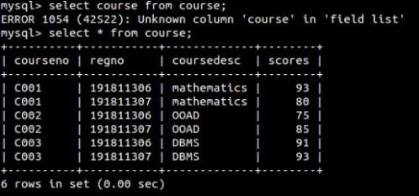

2)

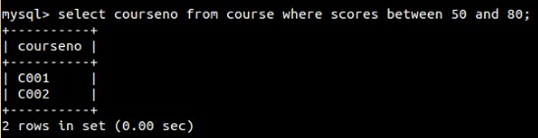

1)

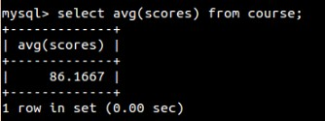

2)

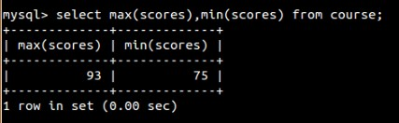

3)

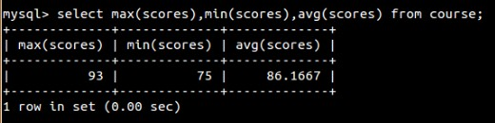

4)

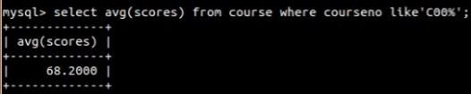

5)

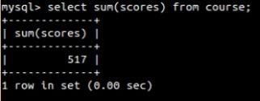

6)

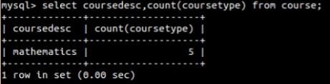

7)

